Q1. Debugging Selection Sort Code
The following Selection Sort code contains logical errors and produces incorrect output for some inputs. Carefully analyze the code, identify all errors in comparison and swapping logic, and explain their root causes. Apply systematic debugging to correct the algorithm step-by-step. Optimize the implementation by reducing unnecessary comparisons if possible. Analyze the corrected algorithm in terms of time complexity. Rewrite the final optimized code with proper structure and comments.
def selection_sort(arr):
n = len(arr)
for i in range(n):
min_idx = i
for j in range(i+1, n):
if arr[j] > arr[min_idx]: # ERROR
min_idx = j
arr[i], arr[min_idx] = arr[min_idx], arr[i]
return arr
ANSWER
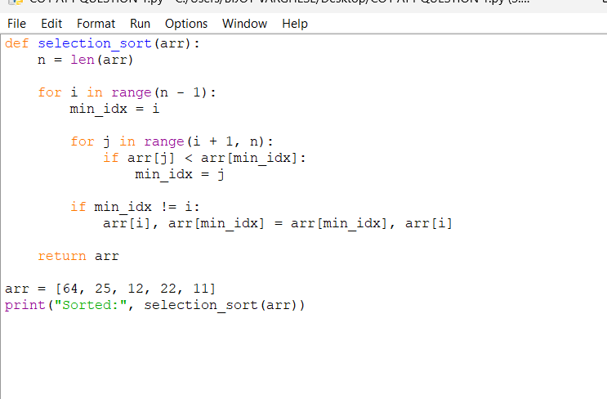
OUTPUT 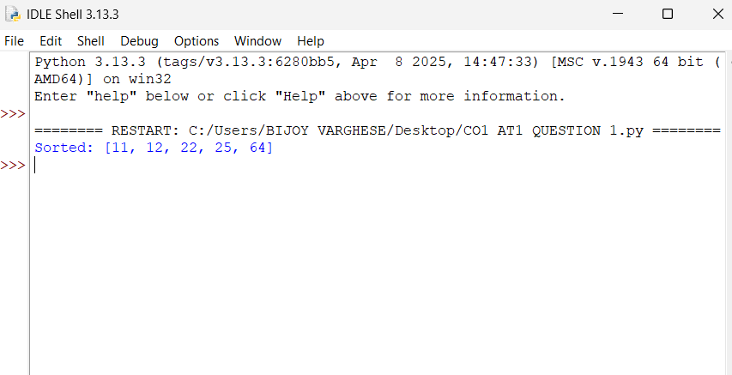

Q2. Debugging Linear Search Code
The given Linear Search implementation fails to return correct results when the element is present and sometimes terminates incorrectly. Identify errors in loop conditions and return statements, and explain their causes. Debug the code to ensure correct functionality. Optimize the implementation for better readability and efficiency. Analyze its time complexity and justify the result. Provide a clean and well-documented corrected version.
def linear_search(arr, key):
for i in range(len(arr)):
if arr[i] == key:
return -1 # ERROR
return i # ERROR
ANSWER 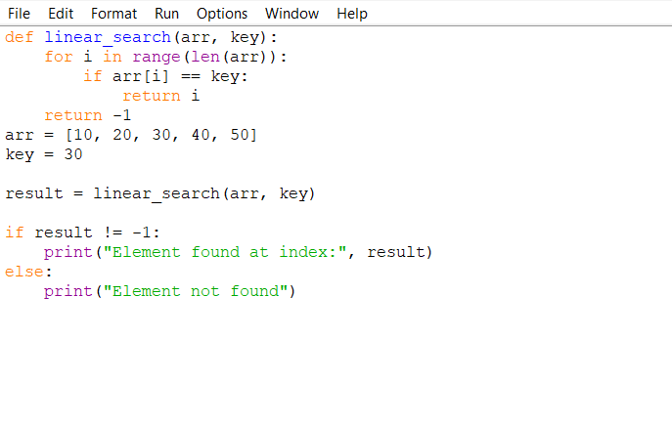

OUTPUT
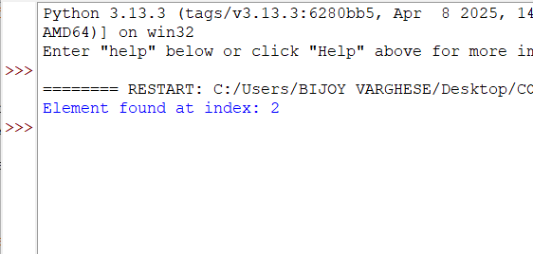
Q5. Debugging Binary Search Code
The following Binary Search implementation fails for certain inputs due to incorrect boundary updates. Identify all logical errors and explain their causes. Debug the code to handle all edge cases correctly. Optimize the implementation to avoid overflow in mid calculation. Analyze its performance in best, average, and worst cases. Rewrite the corrected code with proper documentation.
def binary_search(arr, key):
low, high = 0, len(arr)-1
while low < high:
mid = (low + high) // 2
if arr[mid] == key:
return mid
elif arr[mid] < key:
high = mid - 1 # ERROR
else:
low = mid + 1 # ERROR
return -1

ANSWER
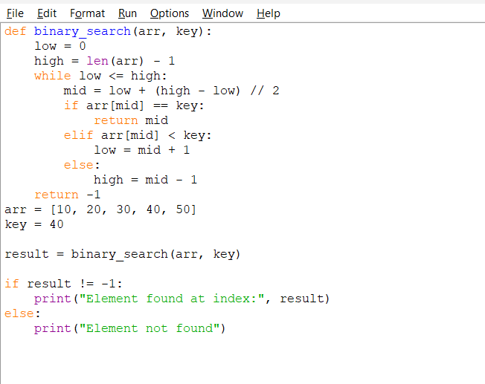
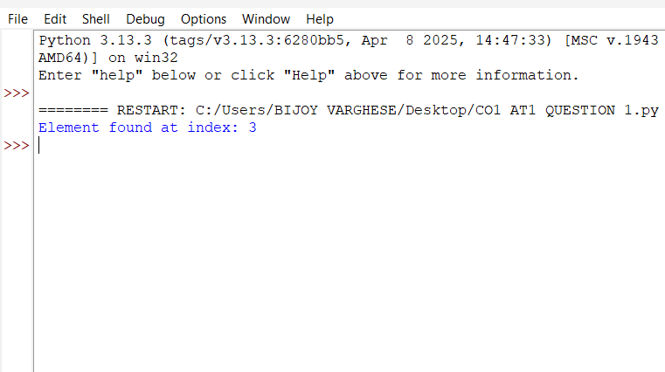
Q6. Debugging Bubble Sort Code
The following Bubble Sort implementation does not correctly sort the array and performs unnecessary iterations. Identify logical errors in loop conditions and swapping mechanism, and explain their causes. Debug the code step-by-step to ensure correct sorting. Optimize the algorithm by reducing unnecessary passes using a flag. Analyze the time complexity of the corrected version. Rewrite the final optimized code with proper comments.
def bubble_sort(arr):
n = len(arr)
for i in range(n):
for j in range(n-1):
if arr[j] < arr[j+1]: # ERROR
arr[j], arr[j+1] = arr[j+1], arr[j]
return arr
ANSWER
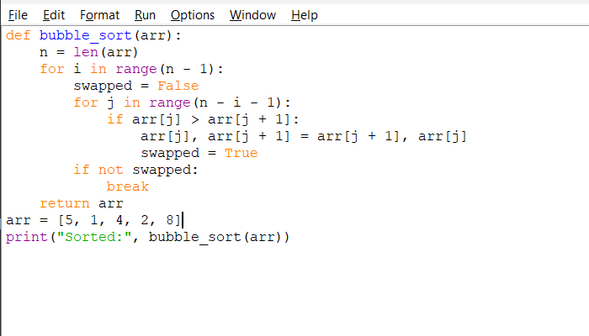
OUTPUT 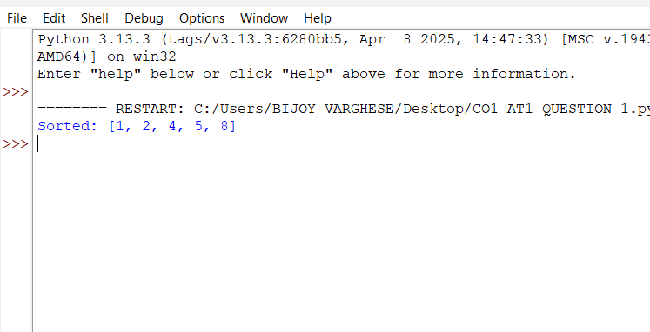

Q7. Debugging Insertion Sort Code
The following Insertion Sort code fails to correctly place elements in sorted order. Identify errors in shifting logic and loop conditions. Explain why incorrect insertion occurs. Debug the algorithm step-by-step to ensure correct functionality. Optimize the code for better readability. Analyze the time complexity. Rewrite the corrected version with proper structure and comments.
def insertion_sort(arr):
for i in range(1, len(arr)):
key = arr[i]
j = i - 1
while j > 0 and arr[j] > key: # ERROR
arr[j+1] = arr[j]
j -= 1
arr[j] = key # ERROR
return arr
ANSWER
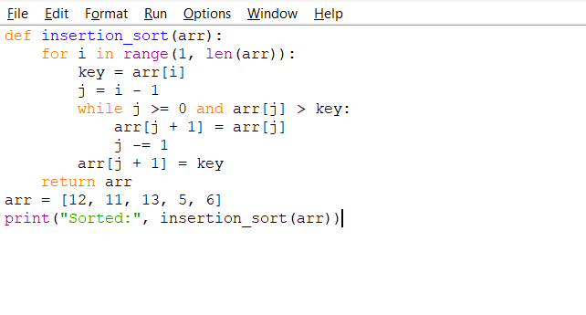
OUTPUT
